**The history of cloud computing**

Data is everywhere and this access to information has become one of the most impactful events in modern history.

We live in the age of ubiquitous cloud computing. It offers agility, lower cost, and better access to resources on a global scale. So how did we get here?

The social benefits of cloud-based data are still being discovered as we continue to explore how our new technological era is evolving. As more and more complex applications are no longer confined to one physical location, this growth is becoming exponential. In our lifetime, we have seen the progression from floppy disc to zip drives, from CDs (and data DVDs) to USB storage drives and beyond. While Millennial may believe that the cloud belongs to their generation, the roots of non-local computing can be traced back to the early 1950s.

**MILITARY REQUIREMENTS**

Originally a military mainframe which was developed in 1950 to connect computer terminals across an internal matrix, non-local storage technology advanced quickly once it hit the scientific community. This was an important consideration back at a time when computing had cost several million dollars and the need for multiple people to access the technology became a necessity.

The term “cloud computing” itself was [coined in 1996](https://www.technologyreview.com/s/425970/who-coined-cloud-computing/) within a Compaq internal document. The term “cloud” was originally linked to the concept of distributed computing, which went mainstream at Apple-spawned General Magic in the early 1990s, with even earlier mentions in academic work before that. The concept was initially discussed by J.C.R. Licklider, the first director of Information Processing Techniques Office at the Pentagon’s ARPA division in the 1960s, according to [Computerworld](https://www.computerworld.com/article/3412271/the-history-of-cloud-computing--a-timeline-of-key-moments-from-the-1960s-to-now.html).

Licklider’s idea went on to revolutionise computing when, in 1969, [Bob Taylor](https://en.wikipedia.org/wiki/Robert_Taylor_(computer_scientist)) and [Larry Roberts](https://en.wikipedia.org/wiki/Lawrence_Roberts_(scientist)) developed ARPANET (Advanced Research Projects Agency Networks) and, eventually, became the precursor of what we call the internet.

The decades following the 1970s saw the development of various Virtual Machines (VMs) like those created by computer giants like IBM.elecommunications followed suit and started to offer virtual private networks (VPNs) to the marketplace.

**THE ARRIVAL OF SOFTWARE AS A SERVICE (SAAS)**

By the 1990s, huge numbers of personal computers were being connected as the technology became more affordable. Until finally, in 1999, [Sales force](https://www.salesforce.com/) became the first company to offer applications over the internet, heralding the arrival of Software as a Service. Three years later, the industry grew massively with video, music and other media being hosted and delivered online. He creation of UX design meant that lay people were gaining access to data previously reserved for programmers and the code literates.

**THE CLOUD BECOMES A THING**

By the mid-1990s, the term “the cloud” was being used to discuss this new digital sphere. Soon Google and Microsoft were in an arms race to build more and more market share of this virtual environment.

Suddenly, the cloud was everywhere and the expansion of PaaS (Platform-as-a-Service), SaaS, and IaaS (Infrastructure-as-a-Service) became a brand new industry with its offshoot, the cyber-security enterprise.

Everyone was accessing the cloud—for entertainment, healthcare, finance and government and the gold rush to join this new sector was happening at an accelerated rate. The cloud was creating a cultural shift never seen before in the history of humanity. Great things were coming from the humblest of places as the barriers of knowledge were removed and access to information became more common and easy. Small startups were changing the world. Wealth was being created in remote locations and creativity and innovation became the domain of the individual.

On August 25, 2006, Amazon Web Services launched Elastic Compute Cloud (EC2), enabling people to rent virtual computers and use their own programs and applications online; this was quickly followed by Google Docs Services. One year later, binge-watching became a thing when a small start-up called Netflix launched its video streaming website.IBM jumped on the bandwagon with Smart Cloud and Apple launched iCloud. Around the same time, Oracle released its own Cloud.

**Vision of Cloud Computing:**

1. Cloud computing provides the facility to provision virtual hardware, runtime environment and services to a person having money.
2. These all things can be used as long as they are needed by the user.
3. The whole collection of computing system is transformed into collection of utilities, which can be provisioned and composed together to deploy systems in hours rather than days, with no maintenance cost.
4. The long term vision of a cloud computing is that IT services are traded as utilities in an open market without technological and legal barriers.
5. In the future, we can imagine that it will be possible to find the solution that matches with our requirements by simply entering out request in a global digital market that trades with cloud computing services.
6. The existence of such market will enable the automation of discovery process and its integration into its existing software systems.
7. Due to the existence of a global platform for trading cloud services will also help service providers to potentially increase their revenue.
8. A cloud provider can also become a consumer of a competition service in order to fulfill its promises to customers.
9. In the near future we can imagine a solution that suits our needs by simply applying our application to the global digital market for cloud computing services.
10. The presence of this market will enable the acquisition process to automatically integrate with its integration into its existing software applications. The availability of a global cloud trading platform will also help service providers to increase their revenue.
11. A cloud provider can also be a buyer of a competitive service to fulfill its promises to customers.

**There are basically 5 essential characteristics of Cloud Computing.** **National Institute of Standards Technology (NIST) lists this characterstics.**

* **On-demand self-services:**

The Cloud computing services does not require any human administrators, user themselves are able to provision, monitor and manage computing resources as needed.

* **Broad network access:**

The Computing services are generally provided over standard networks and heterogeneous devices.

* **Rapid elasticity:**

The Computing services should have IT resources that are able to scale out and in quickly and on as needed basis. Whenever the user requires services it is provided to him and it is scale out as soon as its requirement gets over.

* **Resource pooling:**

The IT resource (e.g., networks, servers, storage, applications, and services) present are shared across multiple applications and occupant in an uncommitted manner. Multiple clients are provided service from a same physical resource.

* **Measured service:**

The resource utilization is tracked for each application and occupant; it will provide both the user and the resource provider with an account of what has been used. This is done for various reasons like monitoring billing and effective use of resource.

**What is Cloud Computing Reference Model?**

The cloud computing reference model is an abstract model that divides a cloud computing environment into abstraction layers and cross-layer functions to characterize and standardize its functions. This reference model divides cloud computing activities and functions into three cross-layer functions and five logical layers.

Each of these layers describes different things that might be present in a cloud computing environment, such as computing systems, networking, storage equipment, virtualization software, security measures, control and management software, and so forth. It also explains the connections between these organizations. The five layers are the Physical layer, virtual layer, control layer, service orchestration layer, and service layer.

Cloud Computing reference model is divided into 3 major service models:

Software as a Service (SaaS)

Platform as a Service (PaaS)

Infrastructure as a Service (IaaS)

The below diagram explains the cloud computing reference model:

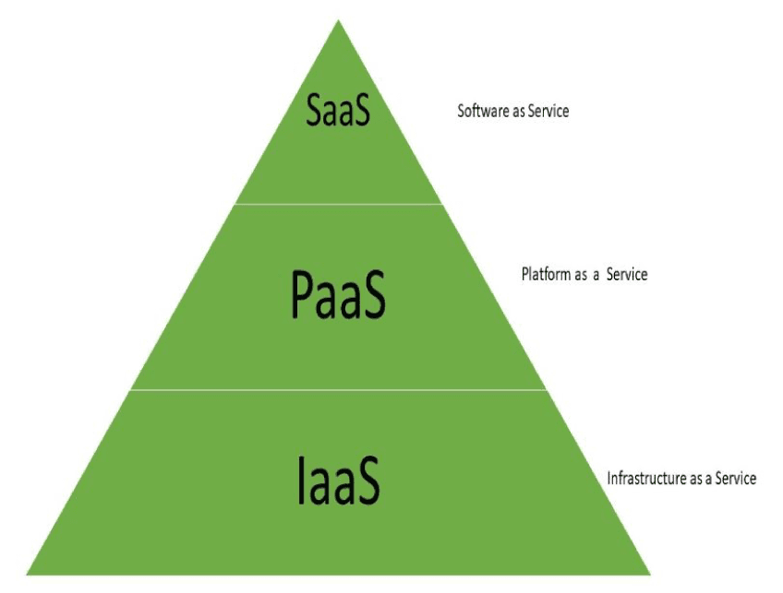

Cloud Computing Reference Model Overview

IaaS, PaaS, and SaaS are the three most prevalent cloud delivery models, and together they have been widely adopted and formalized. A cloud delivery service model is a specific, preconfigured combination of IT resources made available by a cloud service provider. But the functionality and degree of administrative control each of these three delivery types offer cloud users varies.

These abstraction layers can also be considered a tiered architecture, where services from one layer can be combined with services from another, for example, SaaS can supply infrastructure to create services from a higher layer. Let us have a look at the layers of cloud computing reference model.

1. **SaaS**

Software as a Service (SaaS) is a form of application delivery that relieves users of the burden of software maintenance while making development and testing easier for service providers.

The cloud delivery model's top layer is where applications are located. End customers get access to the services this tier offers via web portals. Because online software services provide the same functionality as locally installed computer programs, consumers (users) are rapidly switching from them. Today, ILMS and other application software can be accessed via the web as a service.

In terms of data access, collaboration, editing, storage, and document sharing, SaaS is unquestionably a crucial service. Email service in a web browser is the most well-known and widely used example of SaaS, but SaaS applications are becoming more cooperative and advanced.

Features of SaaS are as follows:

The cloud consumer has full control over all the cloud services.

The provider has full control over software applications-based services.

The cloud provider has partial control over the implementation of cloud services.

The consumer has limited control over the implementation of these cloud services.

2**. PaaS**

Platform as a Service is a strategy that offers a high level of abstraction to make a cloud readily programmable in addition to infrastructure-oriented clouds that offer basic compute and storage capabilities (PaaS). Developers can construct and deploy apps on a cloud platform without necessarily needing to know how many processors or how much memory their applications would use. A PaaS offering that provides a scalable environment for creating and hosting web applications is Google App Engine, for instance.

Features of PaaS layer are as follows:

The cloud provider has entire rights or control over the provision of cloud services to consumers.

The cloud consumer has selective control based on the resources they need or have opted for on the application server, database, or middleware.

Consumers get environments in which they can develop their applications or databases. These environments are usually very visual and very easy to use.

Provides options for scalability and security of the user’s resources.

Services to create workflows and websites.

Services to connect users’ cloud platforms to other external platforms.

**3. IaaS**

Infrastructure as a Service (IaaS) offers storage and computer resources that developers and IT organizations use to deliver custom/business solutions. IaaS delivers computer hardware (servers, networking technology, storage, and data center space) as a service. It may also include the delivery of OS and virtualization technology to manage the resources. Here, the more important point is that IaaS customers rent computing resources instead of buying and installing them in their data centres. The service is typically

Paid for on a usage basis. The service may include dynamic scaling so that if the customers need more resources than expected, they can get them immediately.

The control of the IaaS layer is as follows:

The consumer has full/partial control over the infrastructure of the cloud, servers, and databases.

The consumer has control over the Virtual Machines' implementation and maintenance.

The consumer has a choice of already installed VM machines with pre-installed Operating systems.

The cloud provider has full control over the data centers and the other hardware involved in them.

It has the ability to scale resources based on the usage of users.

It can also copy data worldwide so that data can be accessed from anywhere in the world as soon as possible.

.**Types of Cloud Computing Reference Model:**

There is various type of cloud computing reference model used based on different requirements of the consumers. The most important type of cloud computing reference model is the cloud reference model in cloud computing. The National Institute of Standards and Technology (NIST) is an organization designed by the US government (USG) agency for the adoption and development of cloud computing standards.

The principles of NIST Cloud computing reference architecture are:

Create a vendor-neutral architecture that adheres to the NIST standard.

Create a solution that does not inhibit innovation by establishing a required technological solution.

The NIST Cloud computing reference architecture provides characteristics like elasticity, self-service, the collaboration of resources, etc.

The service models involved in this architecture are:

* Software as a Service (SaaS)
* Platform as a Service (PaaS)
* Infrastructure as a Service (IaaS)

NIST Cloud computing also has 4 deployment models, which are as follows:

1. **Public**

This is the model where cloud infrastructure and resources are given to the public via a public network. These models are generally owned by companies that sell cloud services.

2. **Private**

This is the model where cloud infrastructure and resources are only accessible by the cloud consumer. These models are generally owned by cloud consumers themselves or a third party.

3. **Community**

This is the model where a group of cloud consumers might share their cloud infrastructure and resources as they may have the same goal and policies to be achieved. These models are owned by organizations or third-party.

4. **Hybrid**

This model consists of a mixture of different deployment models like public, private, or community. This helps in the exchange of data or applications between various models.

